***Project 2 –Gold and Bronze Challenge***

***For Chapter 2***

By: Eric Dockery

Date: 5/21/2015

This project was to implement the BNRItem from chapter two and to complete the bronze and gold challenges associated with the chapter. The bronze challenge was to create a bug in the program by calling an item in the array of BNRItem that was not created and to note the exception that gets thrown due to the out of bounds index. To implement this challenge all was needed was one line of code. The exception that is thrown is ‘NSRangeException’ which lists the index beyond bounds.

Code added:

NSLog(@"%@", items[10]);

---------------------------------------------------------------------

SCREENSHOT:

--------------------------------------------------------------------

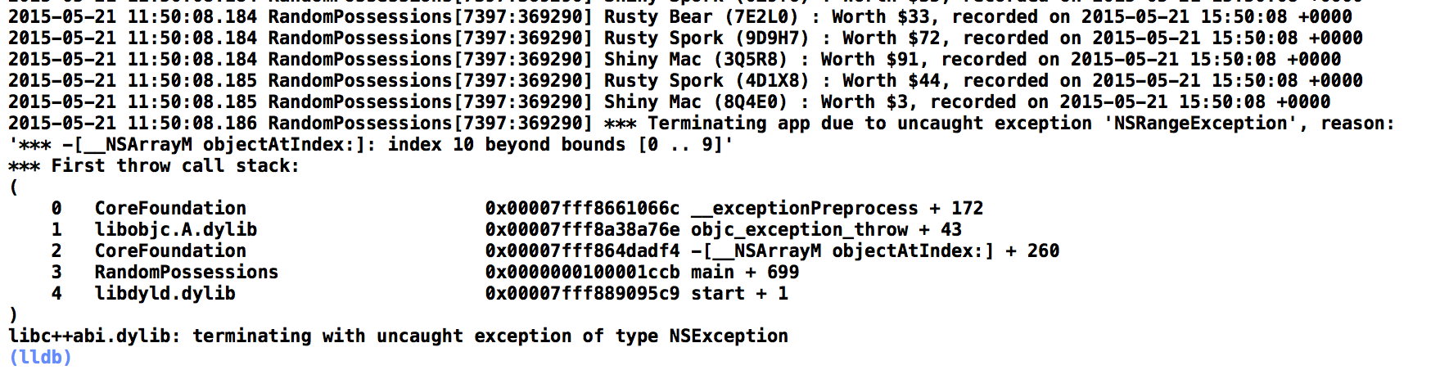

The Gold challenge was to add a subclass of BNRItem named BNRContainer. The BNRContainer class had an array of subitems that contains BNRItems. Printing the description of BNRContainer object shows the name of the container, its value in dollars (a sum of all items in the container plus the value of the container itself), and a list of every instance of BNRItem it contains. A BNRContainer is also able to store other BNRContainers.

To do this you first need to create a new file that is a subclass of the BNRItems, naming it BNRContainers. In your BNRContainer.h file you need to create an NSMutableArray and total value and a string to hold the item descriptions that will be stored.

The tricky part of this is getting the BNRContainers.m file to hold the correct values. To solve this issue I used if statements to determine if the container was holding another container or a item object. This verifies the item and stores the correct date for each call. Then on the description override function I couldn’t quite get the total value to include the value of the container so on the output of the program I just summed the self.totalValue and the self.valueInDollars. This gave the total value of both the container and its contents.

---------------------------------------------------------------------

SCREENSHOT:

--------------------------------------------------------------------

